Naive Bayes Classifier
Teaching Notes
A complete, from-scratch guide to Bayes' theorem and the Naive Bayes classifier, every calculation worked out in full, with diagrams throughout.

Contents

1. Introduction
The Naive Bayes classifier is a probabilistic machine learning algorithm based on Bayes' theorem. It is called naive because it assumes that the features describing an instance are conditionally independent given the class label. While this assumption rarely holds exactly in real-world data, the simplification often works surprisingly well in practice, especially for problems involving high-dimensional data such as text classification.
Naive Bayes has been successfully applied to spam filtering, document categorization, medical diagnosis, and sentiment analysis. Its strengths include computational efficiency, ease of implementation, and good performance even with relatively small training datasets.

2. Bayes' Theorem
Bayes' theorem provides a mathematical framework for updating the probability of a hypothesis in light of new evidence.

Mathematical Form
P( h | D ) = P( D | h ) × P( h ) ÷ P( D )
- P(h) is the prior probability of the hypothesis, before observing any data.
- P(D | h) is the likelihood: the probability of observing data D if h is true.
- P(D) is the evidence: the overall probability of observing data D, across every possible hypothesis.
- P(h | D) is the posterior: the updated probability of h after observing D, this is what we are actually trying to compute.

In words: start with what you believed before (the prior), see how well the evidence fits that belief (the likelihood), and end up with an updated belief (the posterior).

Intuitive Example: Two Bags of Balls
Imagine two bags of balls:

Bag | Red Balls | Blue Balls
A | 7 | 3
B | 4 | 6

You pick one of the two bags at random (so each is equally likely), then draw a ball from it without looking at the bag. The ball turns out to be red. Which bag did it more likely come from?
- P(A) = 0.5 — the prior: before we saw the ball, both bags were equally likely.
- P(Red | A) = 7 ÷ 10 = 0.7 — the likelihood: if it is Bag A, 70% of its balls are red.
- P(Red) = (0.7 × 0.5) + (0.4 × 0.5) = 0.55 — the evidence: overall probability of drawing red, from either bag.
- P(A | Red) = (0.7 × 0.5) ÷ 0.55 ≈ 0.636 — the posterior.

So after seeing a red ball, our belief that it came from Bag A rises from 50% to about 63.6%.
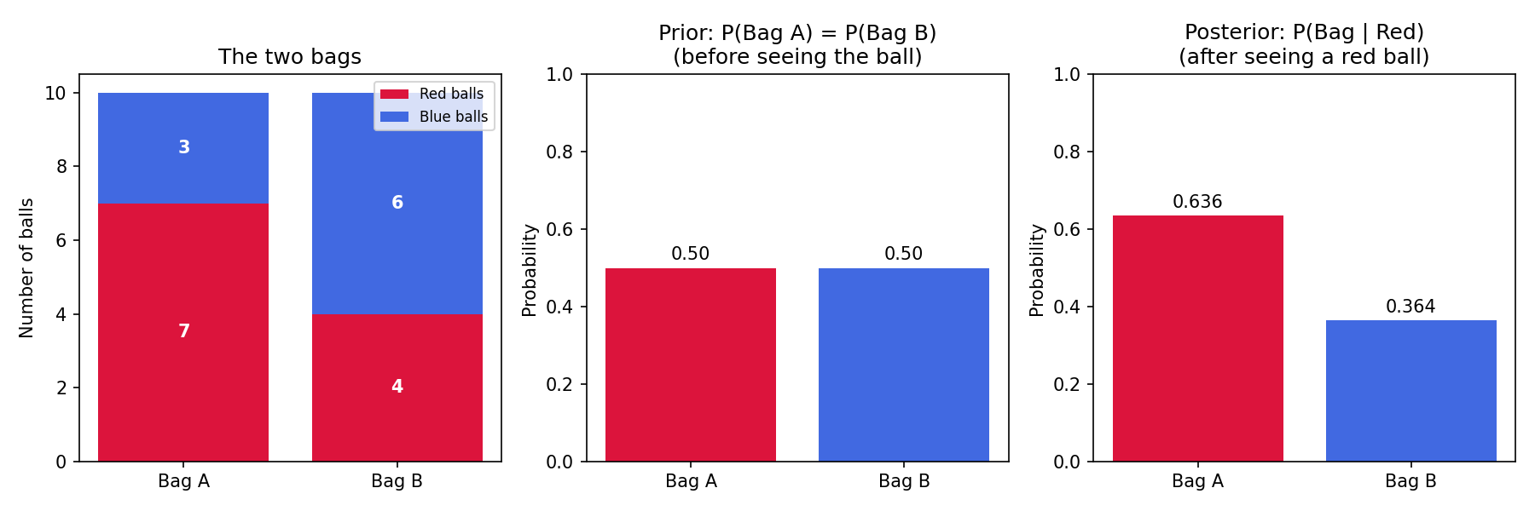
Figure 1. Prior belief (50/50) shifts to posterior belief (63.6% / 36.4%) after observing one red ball.

3. The Naive Bayes Classifier

The Naive Independence Assumption
In classification, our “hypothesis” is which class the instance belongs to, and our “data” is the instance's feature vector X = ⟨a₁, a₂, …, aₙ⟩. Applying Bayes' theorem directly:
P( vⱼ | a₁, a₂, …, aₙ ) = P( a₁, a₂, …, aₙ | vⱼ ) × P( vⱼ ) ÷ P( a₁, a₂, …, aₙ )
The problem: estimating P(a₁, …, aₙ | vⱼ) directly would need enough training examples to cover every combination of feature values, which grows explosively with the number of features. This is where the naive assumption comes in: assume the features are conditionally independent of each other, given the class. That lets us break the joint probability into a simple product:
P( a₁, a₂, …, aₙ | vⱼ ) = P(a₁ | vⱼ) × P(a₂ | vⱼ) × … × P(aₙ | vⱼ)
Instead of needing examples of every combination, we only ever need to estimate each feature's probability on its own, given the class, which needs far less data.

Classification Rule
Since P(a₁, …, aₙ), the evidence, is the same number regardless of which class we're considering, it doesn't affect which class scores highest, so we drop it and simply pick whichever class maximises the numerator:
v_{NB} = the class vⱼ that maximises [ P(vⱼ) × P(a₁|vⱼ) × P(a₂|vⱼ) × … × P(aₙ|vⱼ) ]
In words: for every candidate class, multiply its prior probability by the probability of each observed feature value given that class, then pick the class with the largest result.

4. Worked Example: Weather Data (“Play Tennis”)
We illustrate the Naive Bayes classifier using the classic “Play Tennis” dataset: predicting whether someone plays tennis based on the day's weather.
Outlook | Temperature | Humidity | Windy | Class
Sunny | Hot | High | False | Not Play
Sunny | Hot | High | True | Not Play
Overcast | Hot | High | False | Play
Rain | Mild | High | False | Play
Rain | Cool | Normal | False | Play
Rain | Cool | Normal | True | Not Play
Overcast | Cool | Normal | True | Play
Sunny | Mild | High | False | Not Play
Sunny | Cool | Normal | False | Play
Rain | Mild | Normal | False | Play
Sunny | Mild | Normal | True | Play
Overcast | Mild | High | True | Play
Overcast | Hot | Normal | False | Play
Rain | Mild | High | True | Not Play

Step 1: Prior Probabilities
Out of 14 days, 9 were “Play” and 5 were “Not Play”:
P(Play) = 9 ÷ 14 = 0.6429 P(Not Play) = 5 ÷ 14 = 0.3571

Step 2: Conditional Probability Tables
For each feature, we count how often each of its values occurs, separately within the “Play” rows and the “Not Play” rows, and divide by the class total (9 for Play, 5 for Not Play).
Outlook | Sunny | Overcast | Rain
Play | 2/9 = 0.2222 | 4/9 = 0.4444 | 3/9 = 0.3333
Not Play | 3/5 = 0.6000 | 0/5 = 0.0000 | 2/5 = 0.4000

Temperature | Hot | Mild | Cool
Play | 2/9 = 0.2222 | 4/9 = 0.4444 | 3/9 = 0.3333
Not Play | 2/5 = 0.4000 | 2/5 = 0.4000 | 1/5 = 0.2000

Humidity | High | Normal
Play | 3/9 = 0.3333 | 6/9 = 0.6667
Not Play | 4/5 = 0.8000 | 1/5 = 0.2000

Windy | True | False
Play | 3/9 = 0.3333 | 6/9 = 0.6667
Not Play | 3/5 = 0.6000 | 2/5 = 0.4000

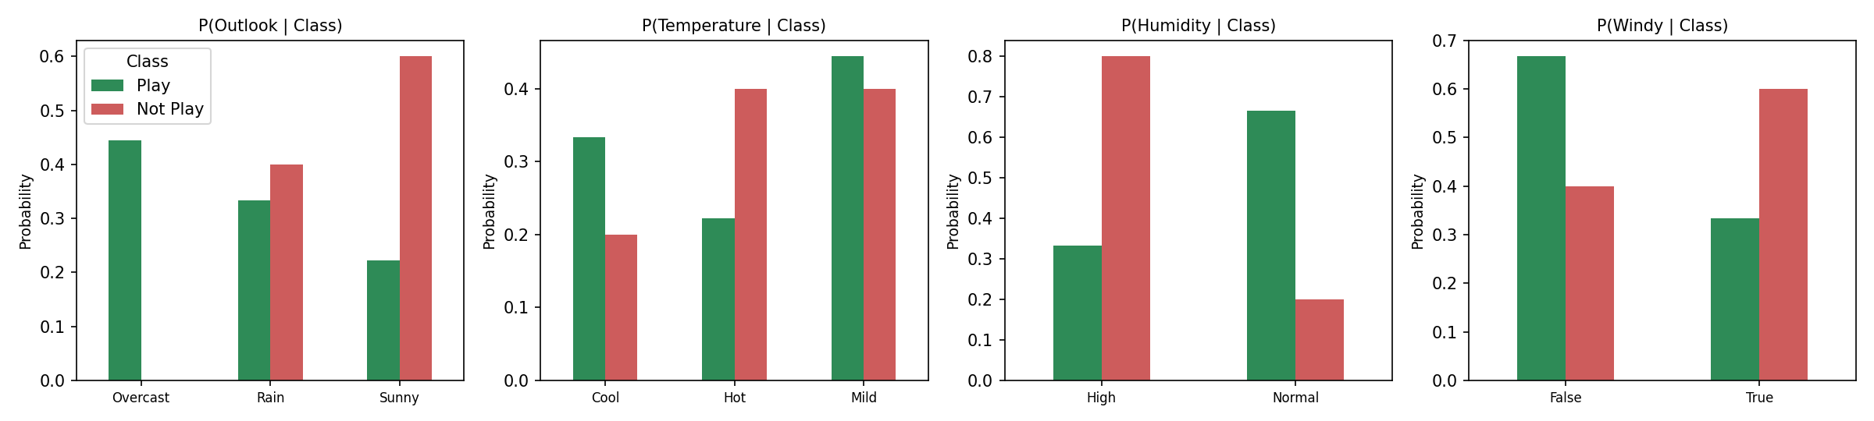
Figure 2. Conditional probability of each feature value, split by class.
One bar is worth pausing on: Outlook = Overcast never occurs on a “Not Play” day in this data, its bar is completely missing on the red side. That gives P(Overcast | Not Play) = 0, a real zero probability sitting in our own table. We return to exactly why that matters in Section 5.

Step 3: Predicting a New Instance
Now, let's predict the class for a new day: X = ⟨Rain, Hot, High, False⟩.
P(Play | X) ∝ P(Rain|Play) × P(Hot|Play) × P(High|Play) × P(False|Play) × P(Play)
= (3/9) × (2/9) × (3/9) × (6/9) × (9/14) ≈ 0.0106
P(Not Play | X) ∝ P(Rain|NP) × P(Hot|NP) × P(High|NP) × P(False|NP) × P(Not Play)
= (2/5) × (2/5) × (4/5) × (2/5) × (5/14) ≈ 0.0183

Step 4: Normalizing
These two numbers are proportional to the true posteriors, but they don't sum to 1, we have been ignoring the shared denominator P(X) (the evidence) from Bayes' theorem, since it is identical for both classes and doesn't change which one wins. To turn them into genuine probabilities that sum to 1, we divide each by their total, the exact same normalizing step as in the bags example above:
P(Play | X) = 0.0106 ÷ (0.0106 + 0.0183) ≈ 0.3666 (36.66%)
P(Not Play | X) = 0.0183 ÷ (0.0106 + 0.0183) ≈ 0.6334 (63.34%)
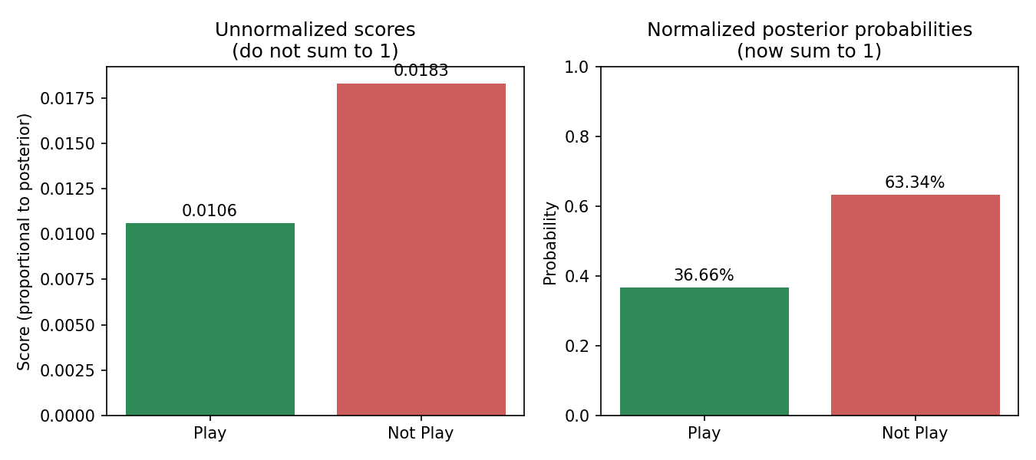
Figure 3. Unnormalized scores (left) and the same scores after normalizing to real probabilities (right).
Since 63.34% > 36.66%, sample X = ⟨Rain, Hot, High, False⟩ is classified as Not Play.

5. Handling Zero Probabilities: Laplace Smoothing
A common problem arises when a particular feature value never occurs with a given class in the training set, its estimated probability comes out as exactly zero. We already spotted this: P(Overcast | Not Play) = 0/5 = 0 in our own weather data.
Why is this a real problem, and not just a curiosity? Because Naive Bayes multiplies the feature probabilities together. If even one of them is zero, the entire product becomes zero, no matter how strongly every other feature points the other way. In practice, this means: any day with Outlook = Overcast can never be classified as “Not Play”, regardless of how bad the rest of the weather looks.

The Fix: Laplace Smoothing
Laplace smoothing (also called add-one smoothing) fixes this by pretending we saw one extra example of every possible feature value, for every class:
P(aᵢ | vⱼ) = ( count(aᵢ, vⱼ) + 1 ) ÷ ( count(vⱼ) + k )
where k is the number of distinct possible values that feature aᵢ can take. Adding 1 to every count means no probability can ever come out as exactly zero, while the +k in the denominator keeps everything correctly normalized (the probabilities across all k values of that feature still sum to 1).

Example 1: A Never-Seen Value (“Snowy”)
Suppose Outlook could also take the value “Snowy”, and it never appeared in the “Play” class. The unsmoothed probability would be 0/9 = 0. With Laplace smoothing, and k = 4 possible Outlook values (Sunny, Overcast, Rain, Snowy):
P(Snowy | Play) = (0 + 1) ÷ (9 + 4) = 1/13 ≈ 0.0769

Example 2: Fixing Our Own Overcast / Not Play Zero
Let's apply the same fix to the real zero we found in our own data, P(Overcast | Not Play), where k = 3 (Sunny, Overcast, Rain are the only Outlook values that actually occur in this dataset):
P(Overcast | Not Play) = (0 + 1) ÷ (5 + 3) = 1/8 = 0.125
A small, non-zero probability instead of a hard zero: an Overcast day can now, in principle, still be classified as “Not Play” if every other feature strongly suggests it, it is just treated as unlikely rather than impossible.

6. Strengths, Weaknesses, and When to Use Naive Bayes

Strengths
- Extremely fast to train and predict: just counting and multiplying, no iterative optimization.
- Works well even with relatively little training data.
- Handles high-dimensional data gracefully (e.g. thousands of words in text classification), since each feature is handled independently.
- Naturally handles categorical features, and multi-class problems, without any extra machinery.

Weaknesses
- The independence assumption is rarely true in practice: correlated features (e.g. Humidity and Outlook, which are often related) get double-counted, which can bias the probabilities.
- Needs Laplace smoothing (or a similar fix) to avoid the zero-probability problem from Section 5.
- The predicted probabilities themselves are often poorly calibrated (the class ranking tends to be reliable even when the exact percentages aren't).

Rule of thumb: reach for Naive Bayes as a fast, strong baseline, especially for text or categorical data, or whenever you need something that trains quickly on a large number of features. If features are heavily correlated with each other, models that don't assume independence (like Decision Trees or Logistic Regression) will usually do better.

7. Summary
Naive Bayes is a classification technique based on Bayes' theorem with an assumption of feature independence. It is fast, simple, and effective for many applications, especially with categorical data and high-dimensional feature spaces. Laplace smoothing ensures robustness against unseen feature values, with k representing the number of possible values for each feature.
Naive Bayes classifiers are easy to implement, and good results are obtained in most cases where the data has a lot of categorical independent variables.

